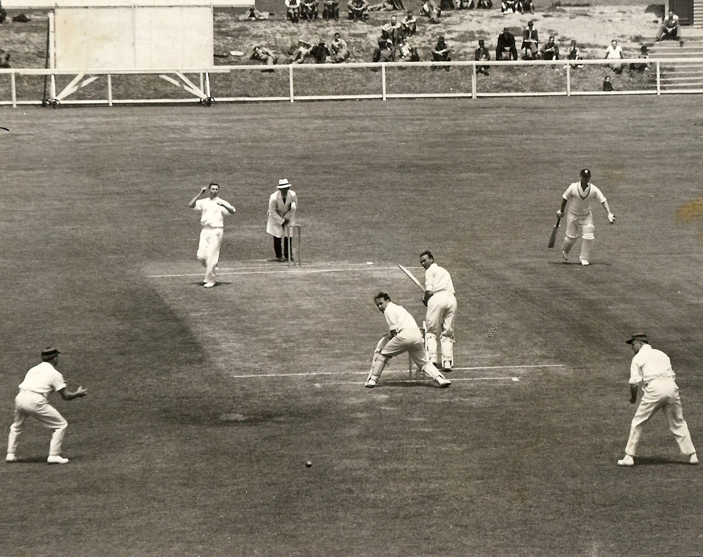

**Canterbury versus Wellington 31 December 1949 Lancaster Park**

Canterbury 326 & 56 Wellington 254 & 134/4. Canterbury lost by six wickets

Murray Chapple the bowler, Bob Webb the keeper